

**RSDS Matlab GUI Project**

**Glossary of Terms and Definitions**

# Definitions

|  |  |
| --- | --- |
| **Abbreviation** | **Description** |
| BLIS | Blind Spot Detection System |
| BSD | Blind Spot Detection - A function that detects object vehicles in the blind spot zone. |
| BSZ | Blind Spot Zone - The zone where the blind spot detection system shall give an alert for a valid object. |
| CVW | Closing Vehicle Warning See FA CVW-:Req24v |
| Host, Ego, or Subject Vehicle | The Host, Ego, or Subject vehicle is your vehicle in which the RSDS system is installed |
| FOV | Field Of View The active view of the sensor that the LCMA system uses. |
| FTP | Functional Test Procedure |
| LCMA | Lane Change and Merge Assist |
| LH | Left Hand |
| RH | Right Hand |
| RSDS | Rear Side Driver Support |
| TBD | To Be Defined |
| Target or Object Vehicle | The Target or Object vehicle is the vehicle that should be seen by the RSDS system |
| TTC | Time To Collision |
| VRU | Vulnerable Road User |

### **Vehicle Coordinate System**

The origin of the Vehicle Coordinate System (VCS) is the center of the front bumper of the host vehicle. Object measurements are reported in Cartesian coordinates located on a straight line X (Longitudinal) and Y (Lateral) axes. Positive x values are forward from the vehicle origin (front bumper) and positive y values are rightward from the vehicle center. Angles clockwise from the x-axis are positive and angles counter-clockwise from the x-axis are negative.

The figure below shows the position of an object track behind a vehicle with respect to the vehicle coordinate system.

**Figure 1.3.1‑1**: Vehicle Coordinate System



**H**

**0,0**

**-x,+y**

**T**

### **Detection Zones**

Two zones are defined for the RSDS system: the BLIS and CVW zones. The diagram below shows the defined zones when the host vehicle is in a forward drive gear. The zones are defined to cover regions surrounding the host vehicle.

**BLIS Zone**

The BLIS Zone is divided into two parts – the may-warn zone and the must-warn zone. Only the may-warn zone is needed for this project. This zone is 3.75m wide by 14m long, offset 0.5 away from the vehicle width, with the front of the zone 0.5m in front of the vehicle mirrors. Specific vehicle sizes are user defined: width (y direction, ~2m), length (x direction, ~5m), and distance from the mirror to the front of the vehicle (x direction, ~1.5m).



**CVW Zone:**

The CVW Zone is laterally located with the BLIS zone, but is ~70m long.

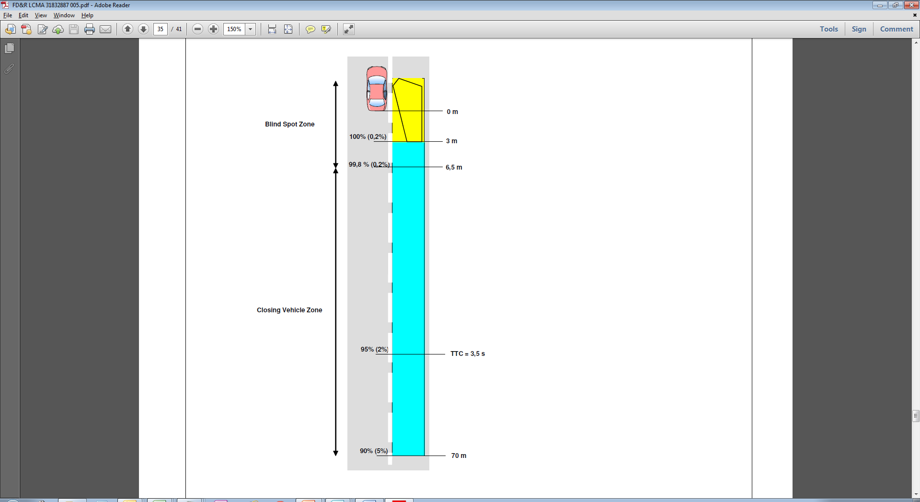

### **Measurement Reference Points**

Objects are tracked as 2-dimensional rectangular objects. Objects have length, width, and a center reference point. The Center Reference Point (CRP) is the measurement point of the estimated object center.

**Figure: Object Reference Points**

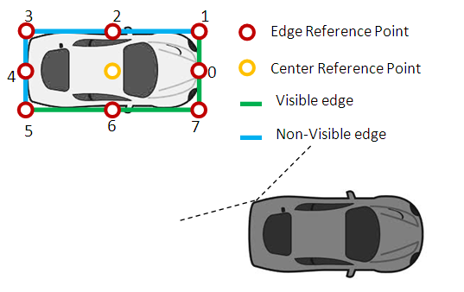

#### Object Heading Angle

The system shall estimate and report the heading angles of the object. The heading angle measurements shall be according to the Vehicle Coordinate System.

The VCS heading angle shall be positive when the object is turning to the right and negative when the object is turning to the right.

**Converting to VCS Coordinates**

The radar parameters are given in range and angle from the radar sensors that are mounted in the back of the vehicle. Therefore, the GUI must convert the radial range measurements of targets detected into the vehicle coordinate system.

##### VCS Lateral Position

Object VCS lateral position measurements shall be according to the Vehicle Coordinate System.

##### VCS Longitudinal Position

Object VCS longitudinal position measurements shall be according to the Vehicle Coordinate System.